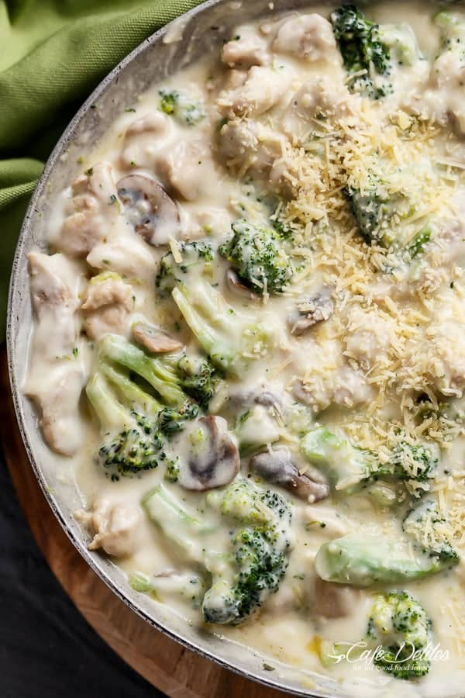
Chicken and Mushrooms in a White Wine Cream Sauce
6 Servings
Ingredients
2 tsp olive oil
21 oz skinless chicken thigh fillets, cubed
1 head of broccoli, cut into florets
7 oz sliced mushrooms
4 garlic cloves, crushed
3 tbsp butter
2 level tbsp flour
1 ¾ cups milk (plus extra if needed)
¼ cup white wine
Parmesan cheese to serve
Directions
- Heat the oil in a large pan over medium heat. Brown the chicken.
- Add the broccoli florets and mushroom slices. Pan fry until the broccoli becomes vibrant in color. Stir in the garlic and fry for about 30 seconds or until fragrant. Set aside.
- In a smaller saucepan, melt the butter over low heat. Remove the pot off the heat. Whisk in the flour until smooth. Return to the heat and pour in ¼ cup of the milk first, stirring quickly to combine until smooth. Add in another ¼ cup of milk, again stirring quickly until smooth. Slowly begin to pour in the remaining milk half a cup at a time while stirring continuously, until all of the milk is in. Keep stirring until the sauce begins to thicken. Mix the white wine through the sauce and continue to stir over low heat.
- Serve over pasta. Top with parmesan cheese.

